*vivo mobile*

vivo y29e

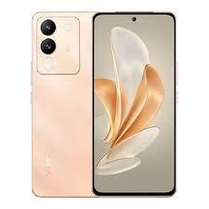

Display ; Size. 6.67 inches ; Resolution. 2400 × 1080 (FHD+) ; Refresh Rate. 120 Hz ; Local Peak Brightness. 1150 nits ; Color Gamut. 100% DCI-P3.

**PRICE /** 99,999 **PRK**